<https://www.youtube.com/watch?v=f1TRWuqioBI&list=PL5nViEmyYI0bmfcM_s4P-dfzKrOpcFWWK&index=28>



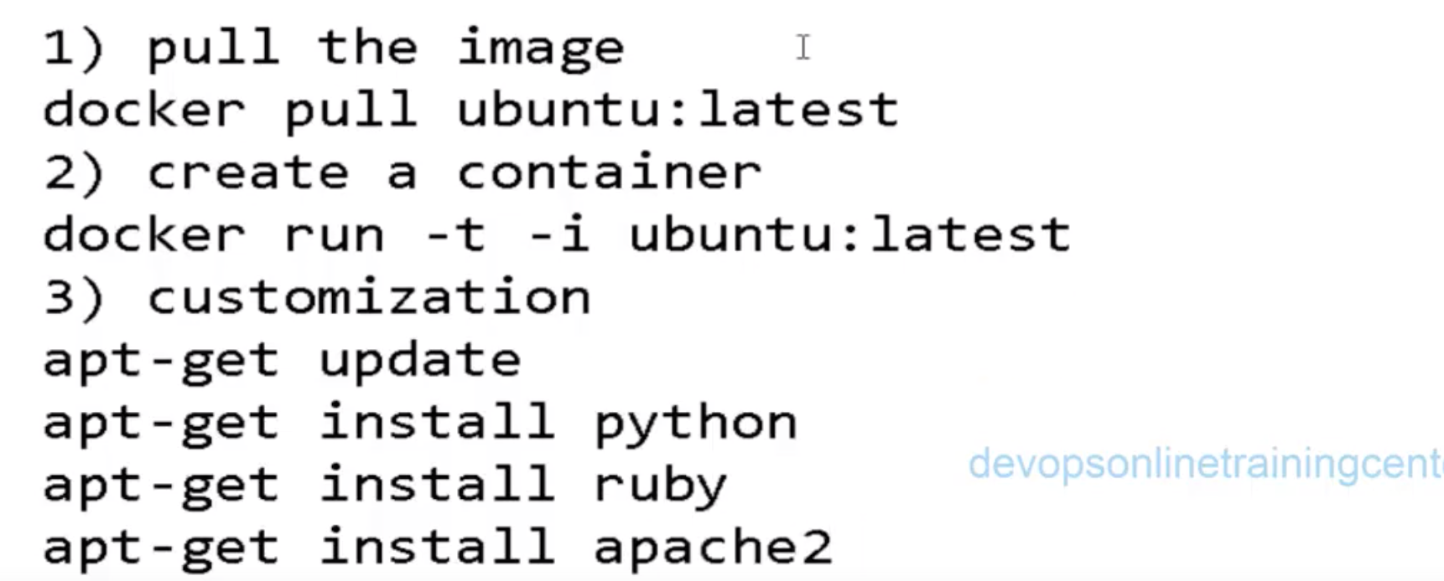

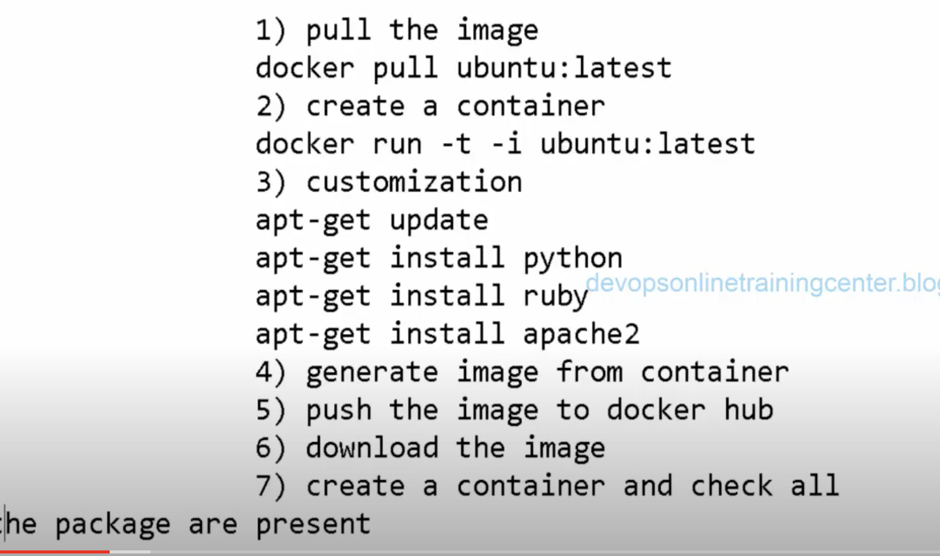

Below command check the docker-container ID. Start it and then switch in that particular container.

Docker start 20442007cfbbe(container name)🡪 start the container.

Docker attach 20442007cfbbe🡪 switch to the container

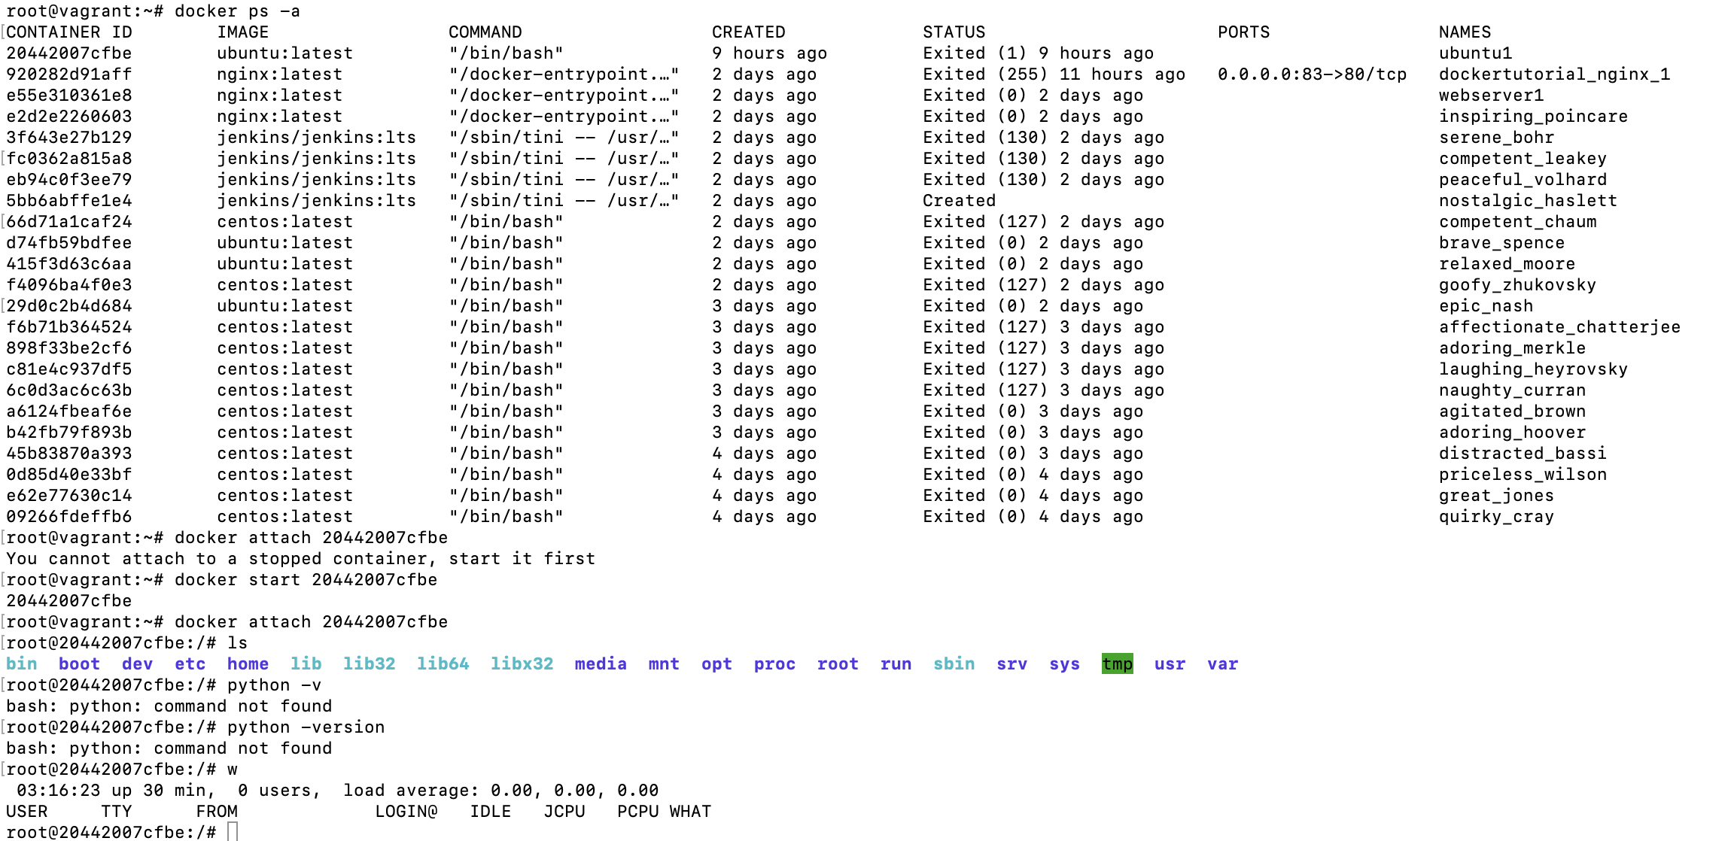

Below command is to check whether ruby, apache2 install on machine or not.



Install the update first, then proceed to install other softwares:

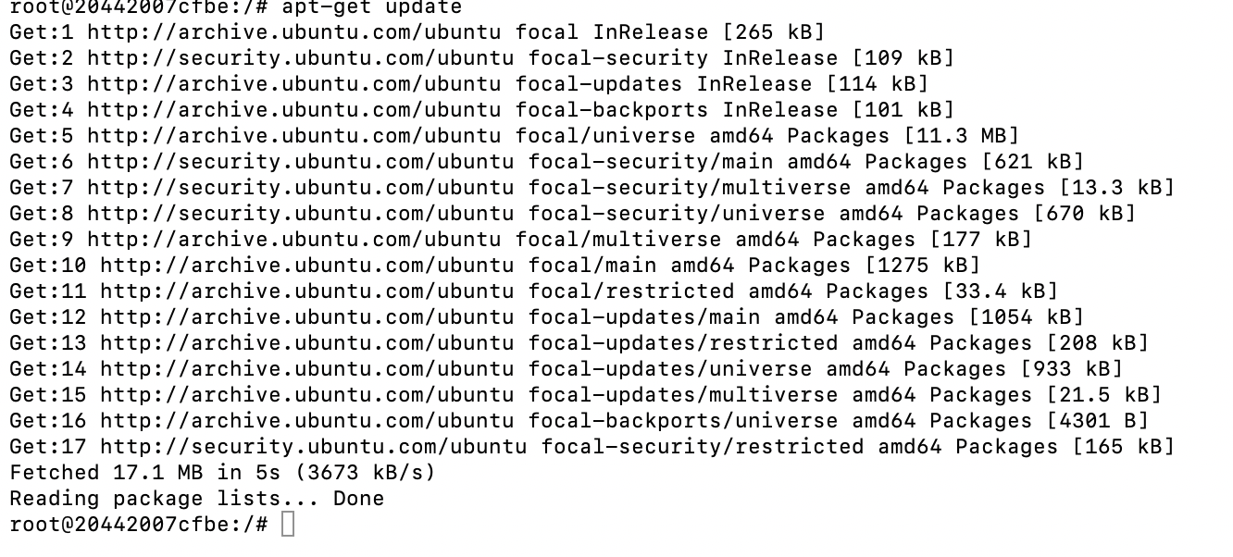

**Install python software: apt-get install python**

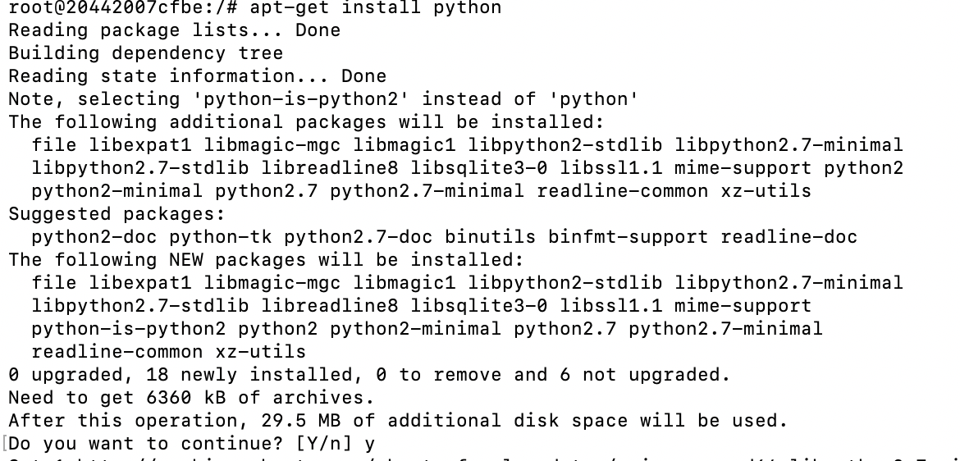

**Install ruby: apt-get install ruby**

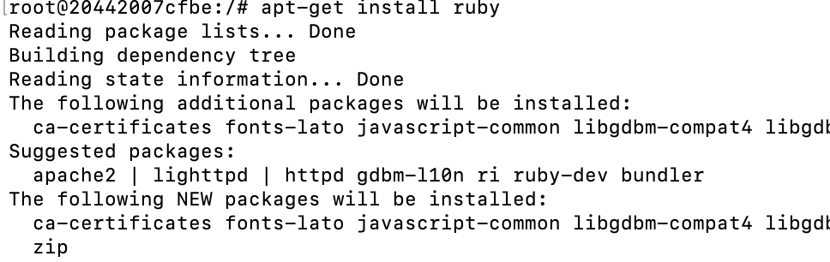

**Install apache2: apt-get install apache2**

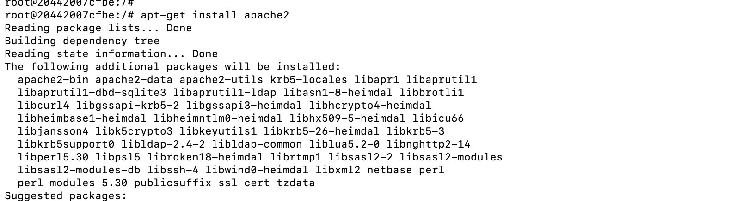

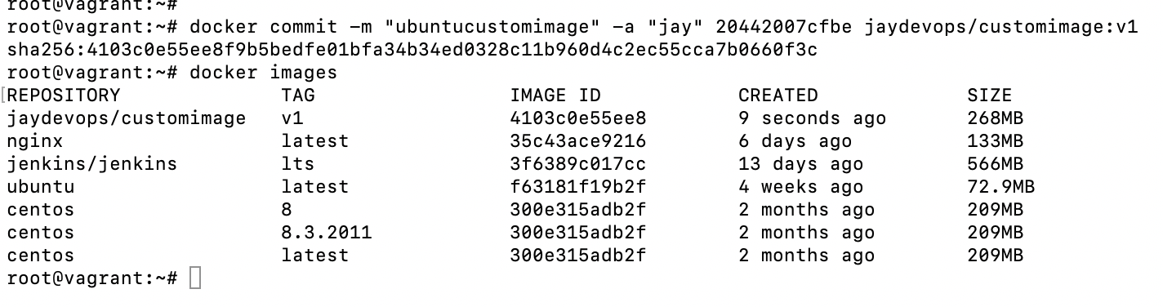

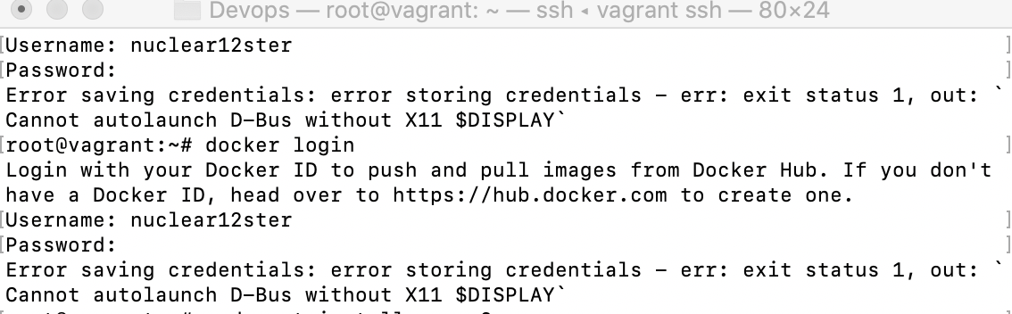

Then install below application from google:

**sudo apt install gnupg2 pass**

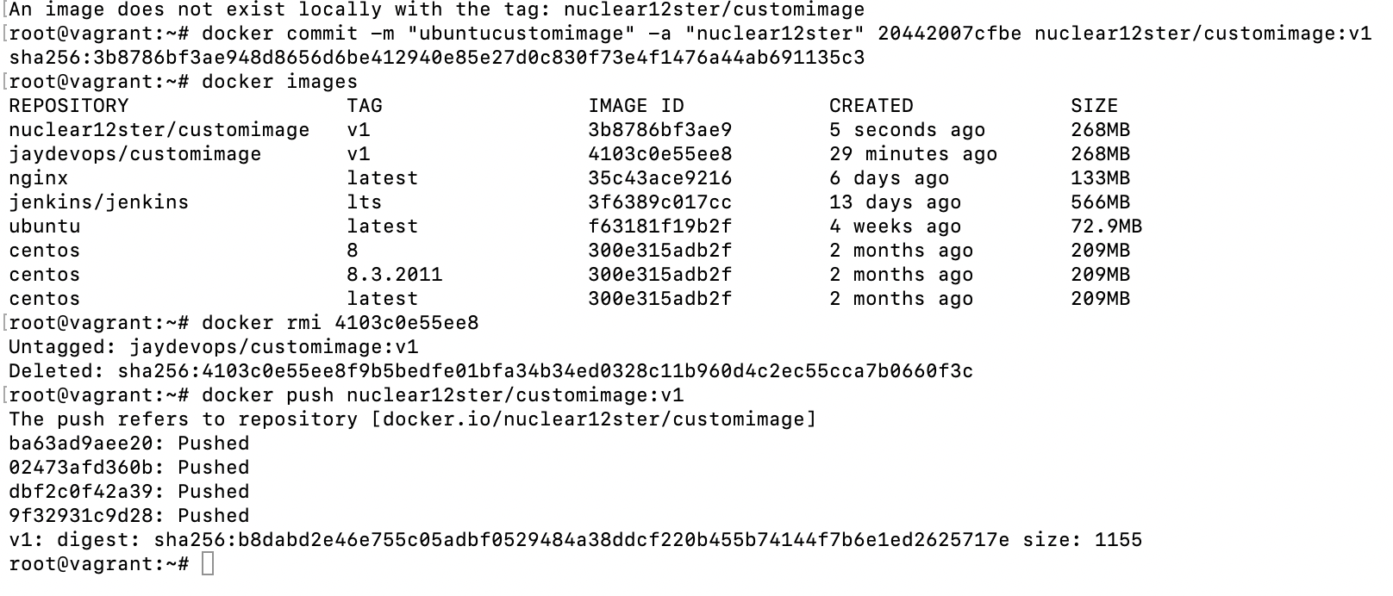

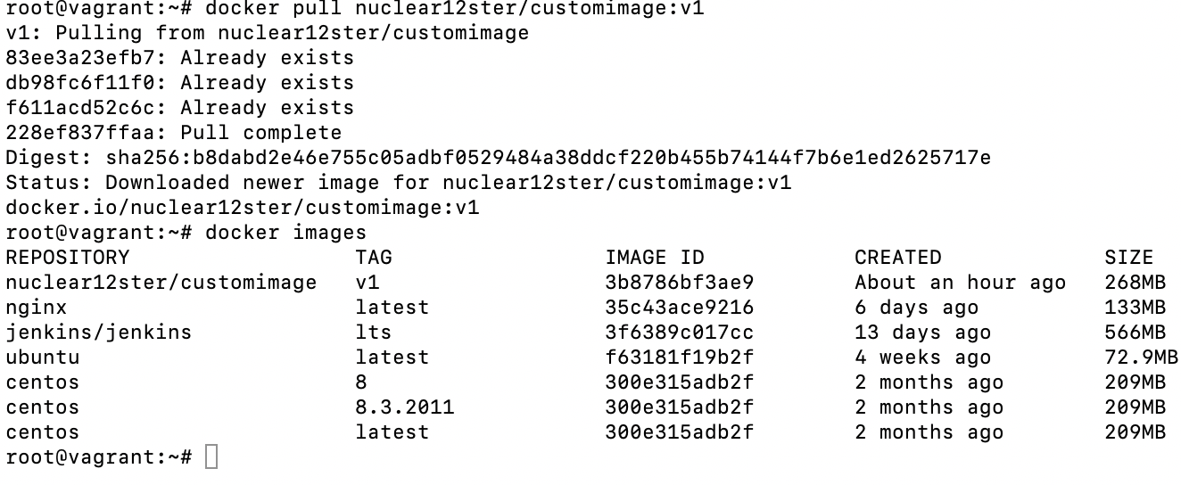

**Now the image got created, then we can create container from this image.**

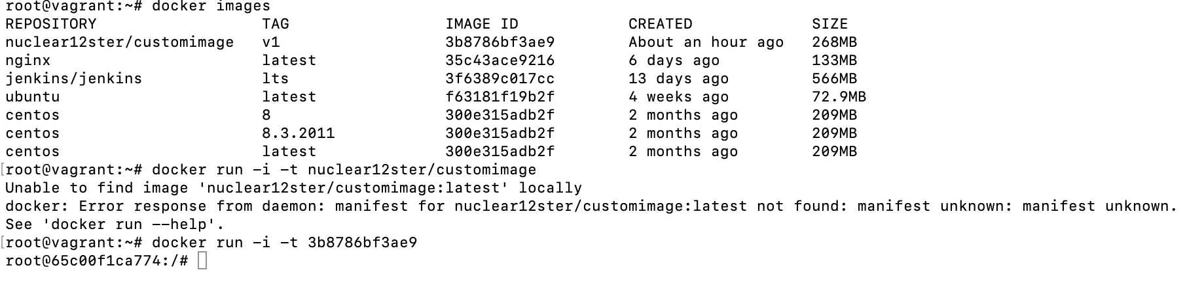

**Now check whether softwares are installed on container or not?**

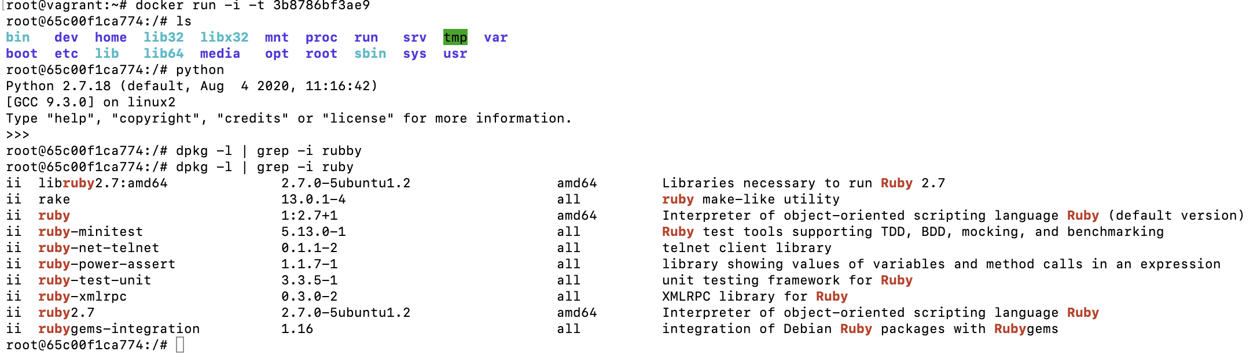

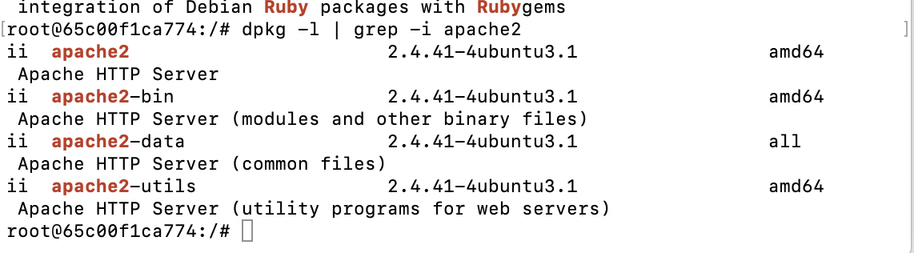

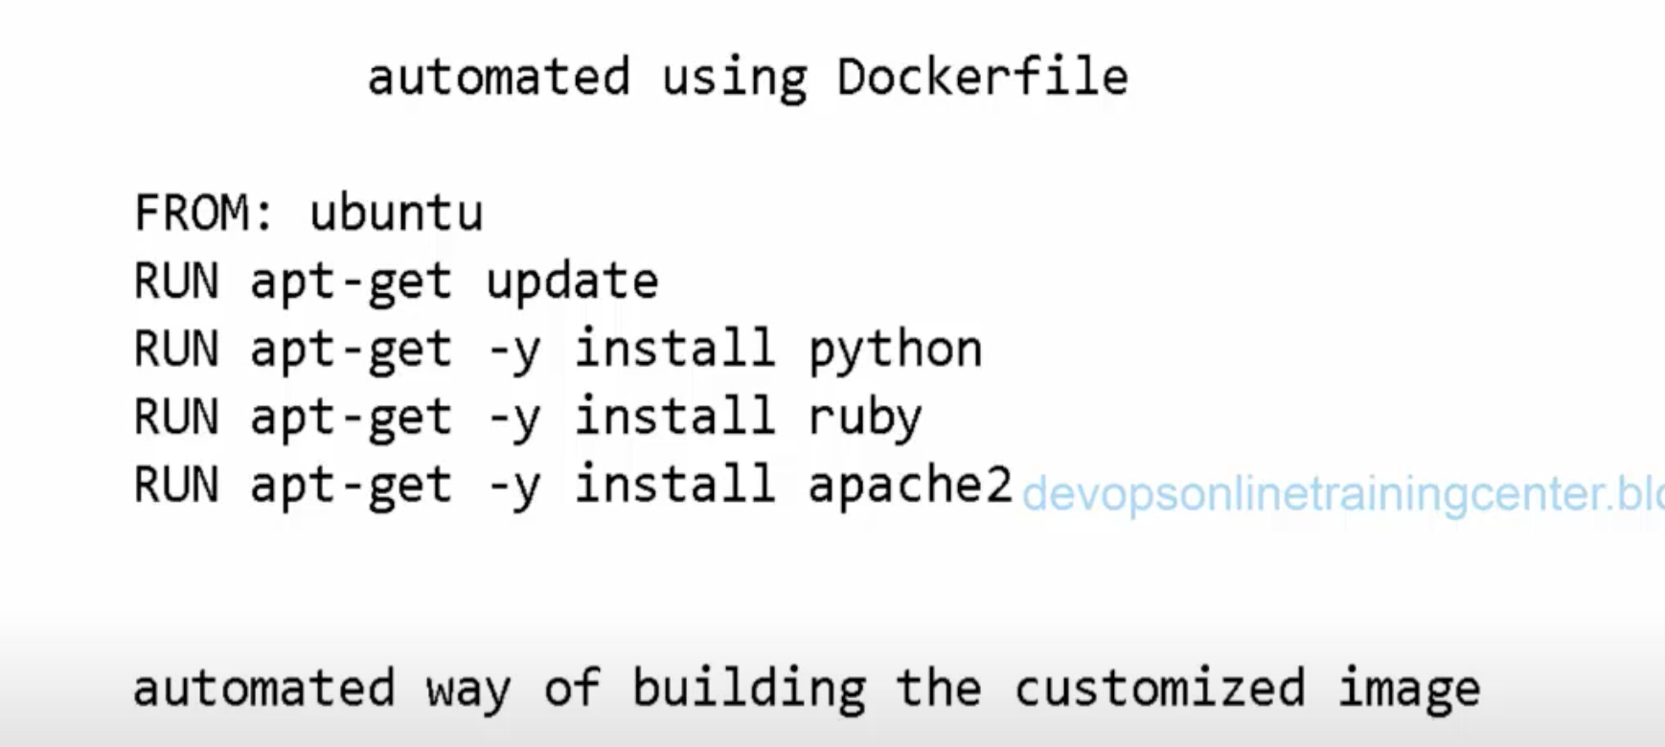

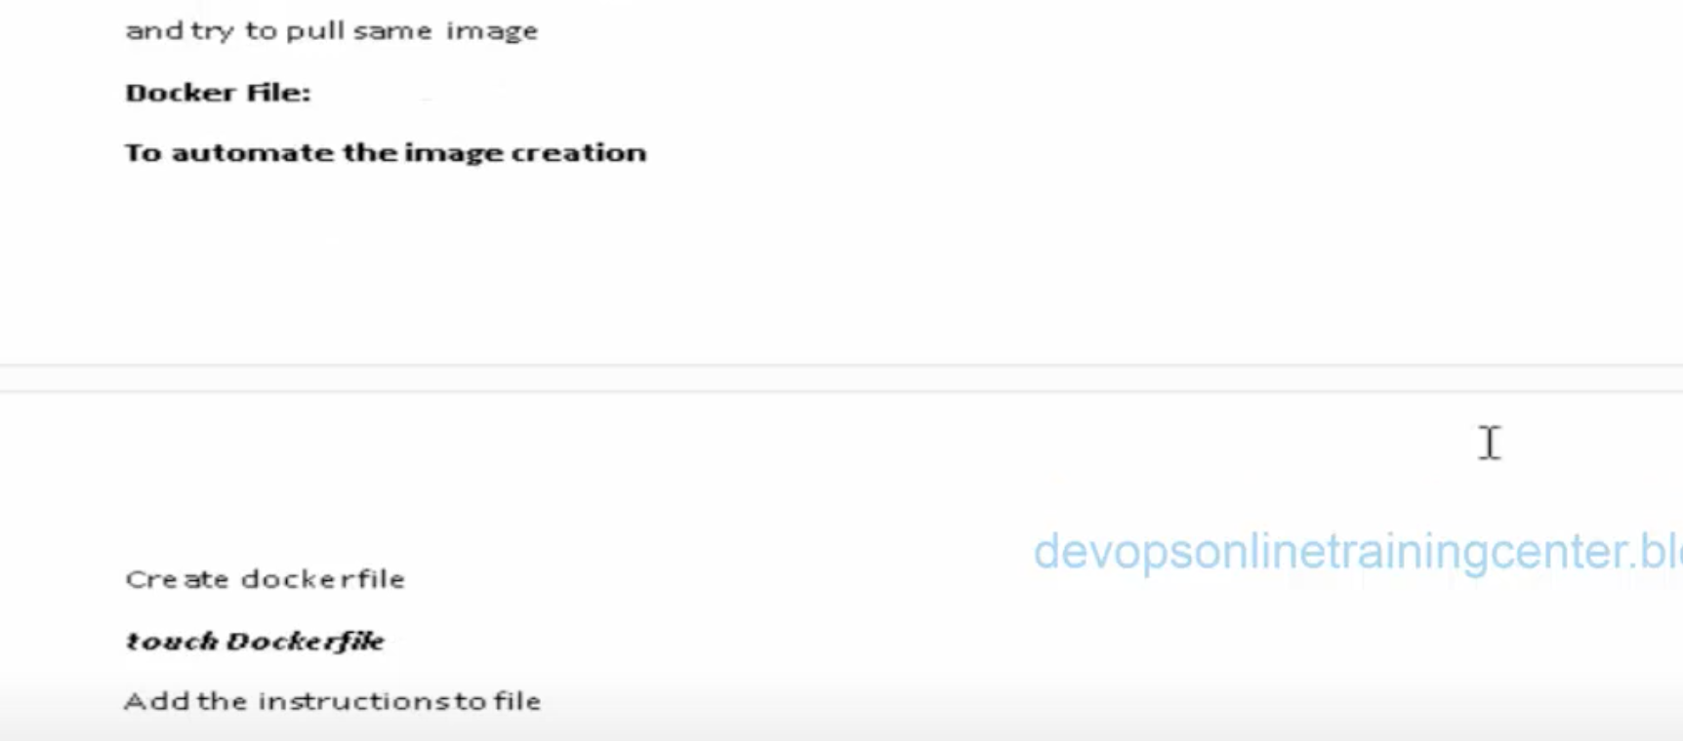

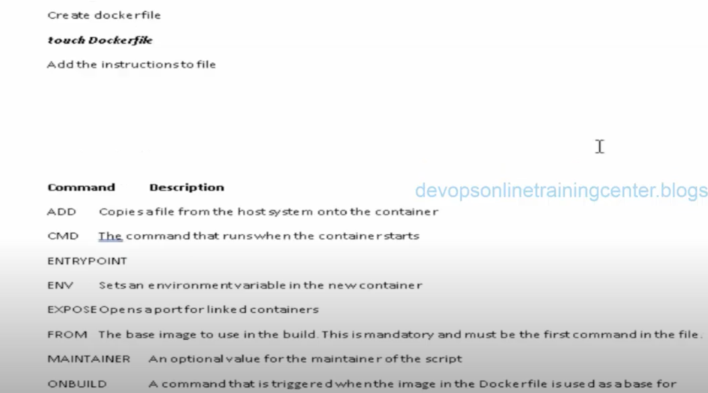

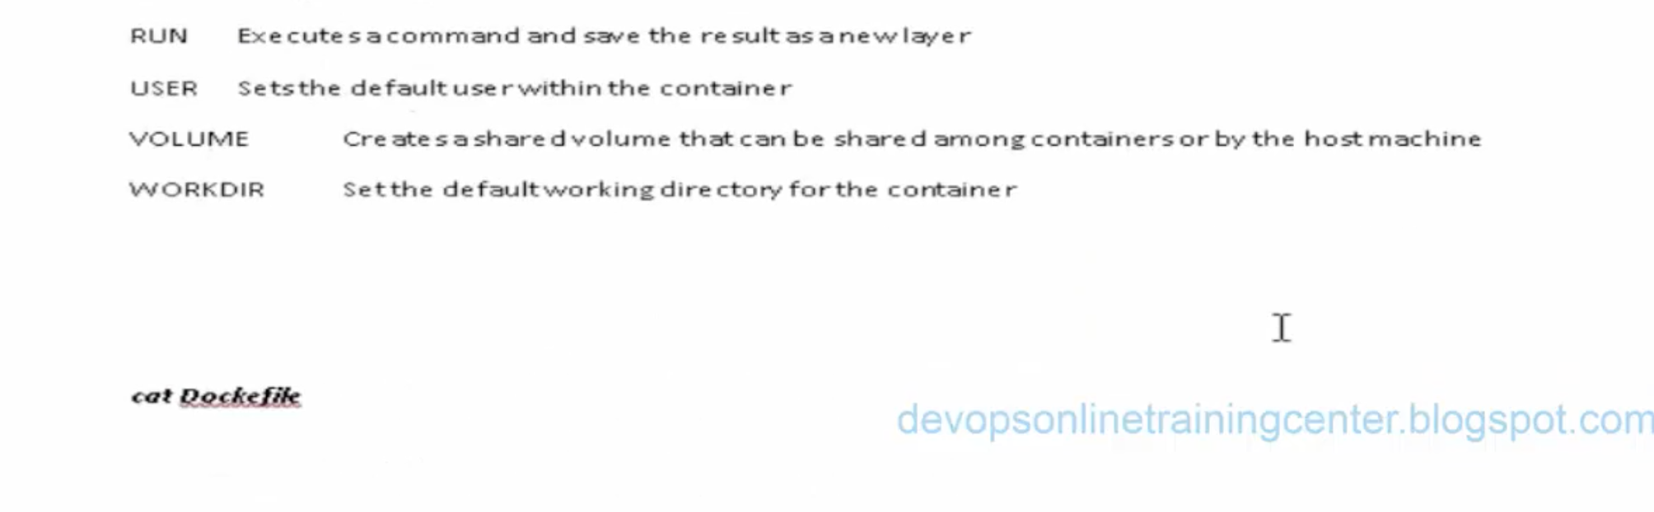

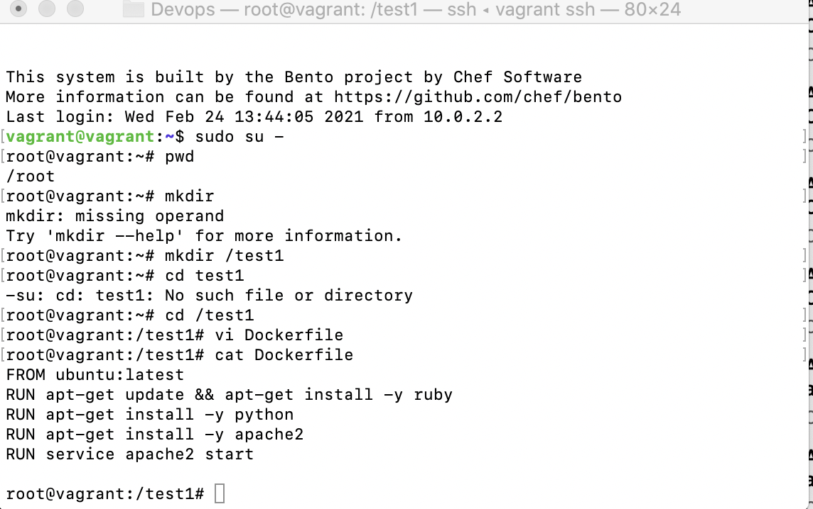

Create the image named customimage2209 and all the commands mentioned in Dockerfile.

(.) Dot denotes that Dockerfile is present in current directory.

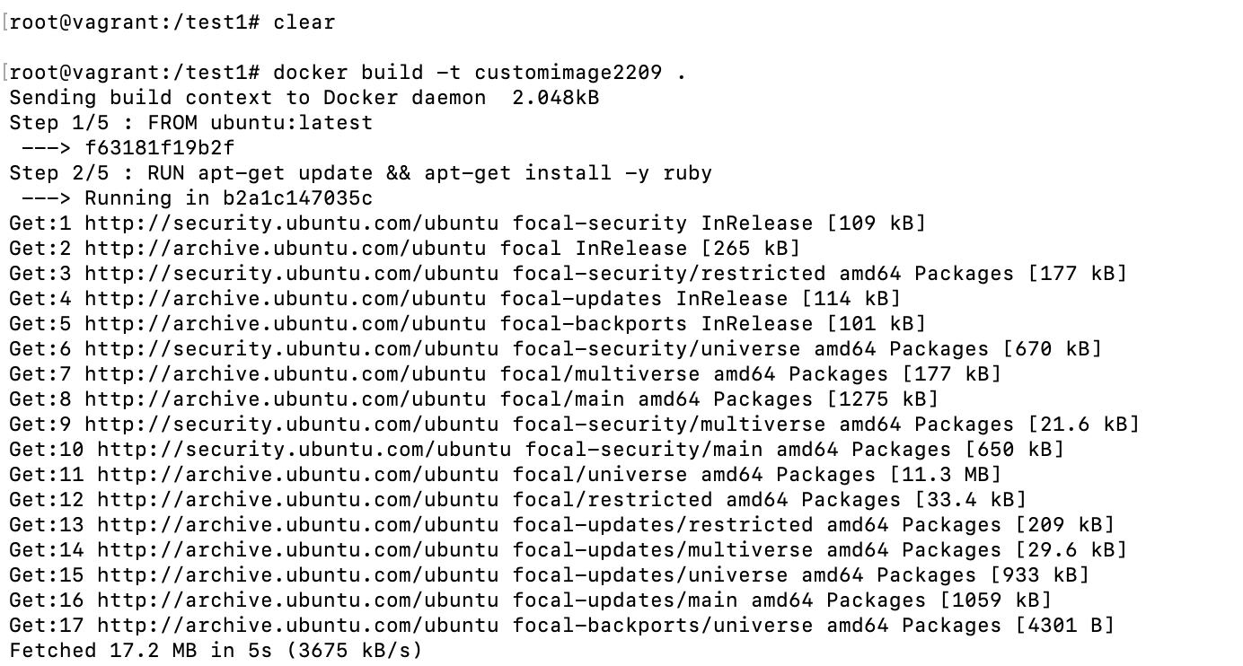

**Docker: configure tzdata and timezone during build**

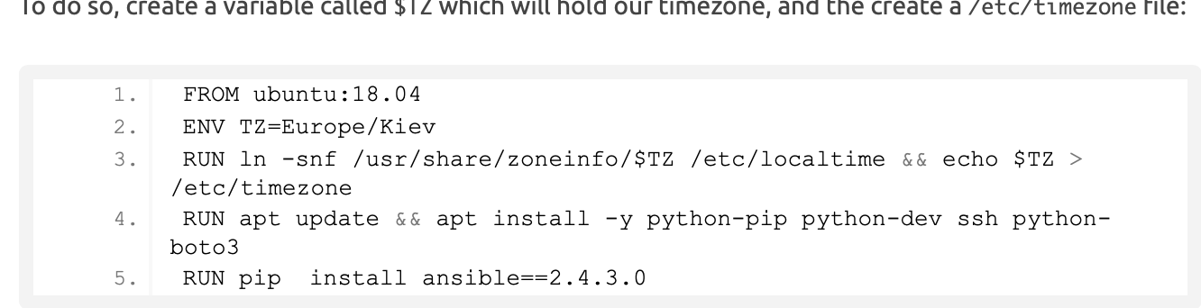

[httpd: Could not reliably determine the server's fully qualified domain name](https://stackoverflow.com/questions/18290683/httpd-could-not-reliably-determine-the-servers-fully-qualified-domain-name)

Instead, edit your hosts file(/etc/hosts) and be sure that you have a FQDN listed there. I have seen various suggestions on the syntax for the particular 127* line, but I think that it doesn't matter what order things are in, so long as there is a FQDN listed:

127.0.0.1 localhost.localdomain localhost foo.example.com

This worked for me and seemed much more to the point than all of the other "worked for me!"

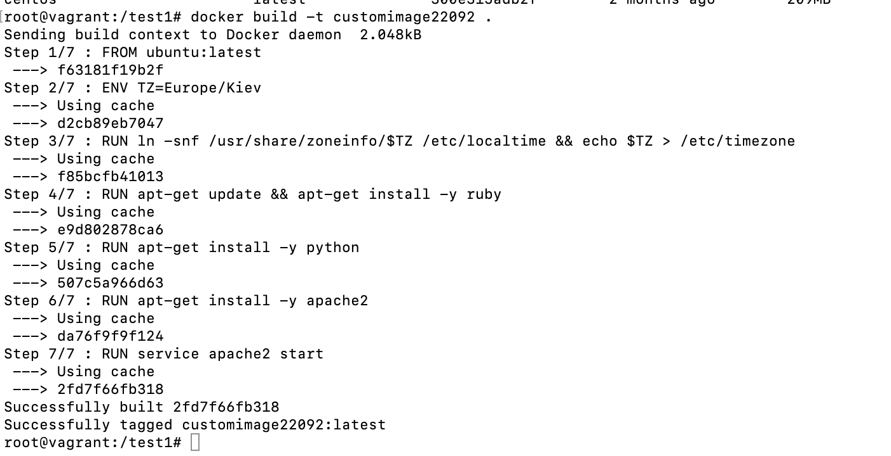

Create new container from images:

$docker container create 2fd7f66fbb318

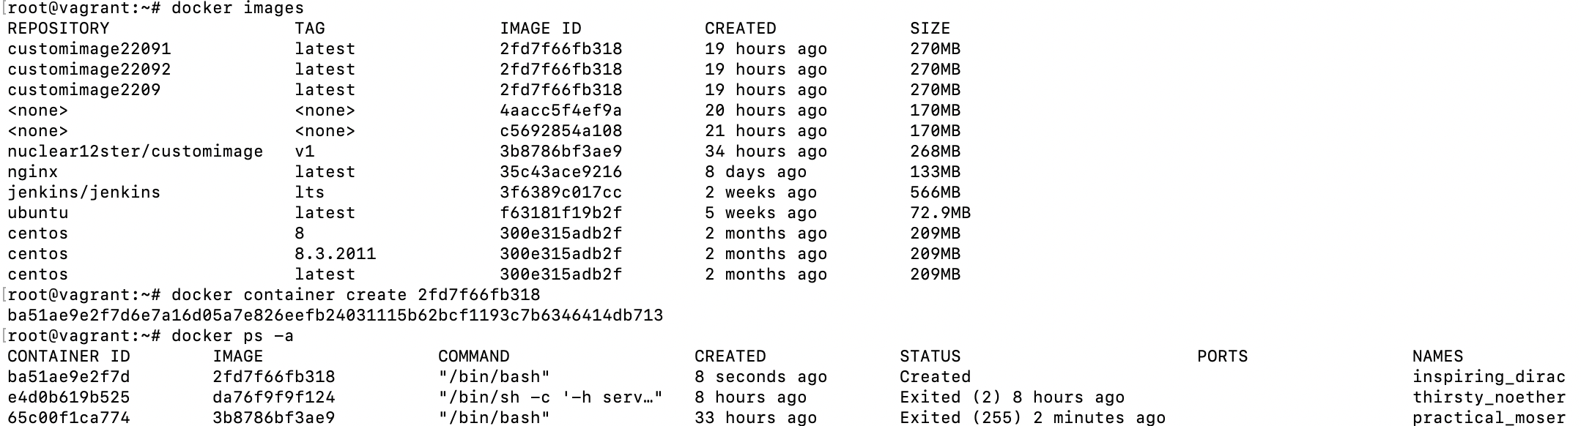

docker run -it <image_id> /bin/bash

# Now check wether softwares are installed or not .

